|  |  |
| --- | --- |
| AIUB-Logo | **WEB TECHNOLOGIES**  **FALL 2021-2022**  **Quiz-1** |

**ID: 20-42195-1 Name: Nafinur Leo**

**Section: E**

1. Consider the following array, $a=array(21,56,34, array(22,67),90, array(1,45)); Write the php code to print the array in the following format. [5]

* a[0]=21
* a[1]=56
* a[2]=34
* a[3]=22,67
* a[4]=90
* a[5]=1,45

Answer:1

<html>

<body>

<?php

$a=array(21,56,34,array(22,67),90,array(1,45));

$l=count($a);

for($m=0;$m<$l;$m++){

if(is_array($a[$m])){

$b=$a[$m];

$l2=count($b);

for($n=0;$n<$l2;$n++)

{

echo $a[$m][$n].", ";

}

echo "<br/>";

}

else

{

echo "a[]=$a[$m]"."<br/>";

}

}

?>

</body>

</html>

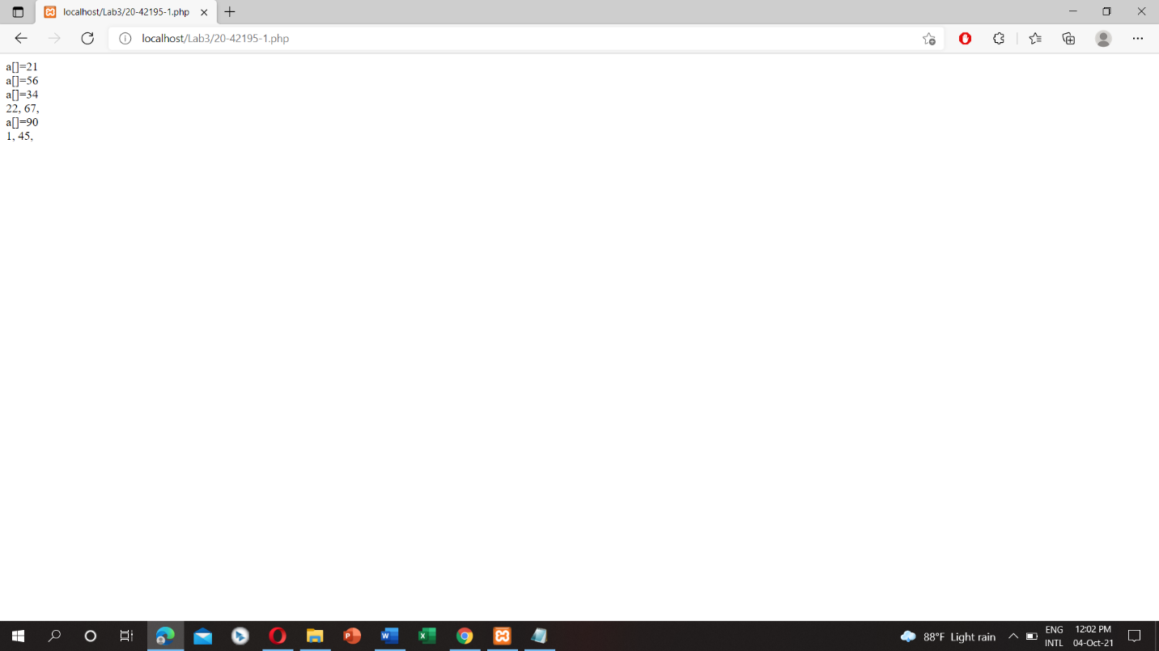

1. Write php code to calculate the addition, average and modulus of the numeric values of the middle portion of your ID. EXAMPLE: Your ID:18-32891-1.

Middle portion: 32891

Addition:3+2+8+9+1

Average: addition/n

Modulus: addition%2

Answer:2

<html>

<body>

<?php

$x=4;

$y=2;

$a=1;

$b=9;

$c=5;

$z=$x+$y+$a+$b+$c;

echo "Sum: ",$z;

?>

</body>

</html>

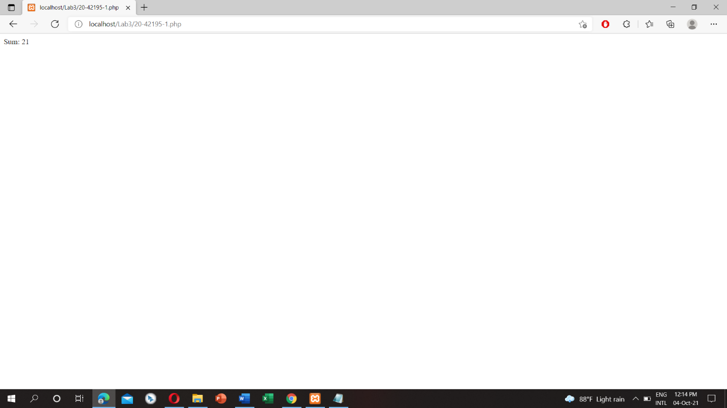

Each of the three functions will be considered as an individual function. [5]

1. Write a php code to generate the following pattern. [5]

*

* *

* * *

* * * *

* * * * *

* * * * *

* * * *

* * *

* *

*

Answer:3

<html>

<body>

<?php

function pattern($len){

$string="*";

$pyramid_str="";

$mid=ceil($len/2);

for($m=1;$m<=$mid;$m++){

for($n = 1; $n <= $m; ++$n) {

$pyramid_str.=$string." ";

}

$pyramid_str.="\r\n";

}

for($m=$mid;$m>=1;$m--){

for($n = 1; $n < $m; ++$n) {

$pyramid_str.=$string." ";

}

$pyramid_str.="\r\n";

}

return $pyramid_str;

}

echo pattern(10);

?>

</body>

</html>

